Iraq University College Journal of Engineering and Applied Sciences

Word Template for Iraq University College Journal of Engineering and Applied Sciences

First A. Author^{1,a}, and Second B. Author^{2,b,*}

1 First A. Authors’ affiliation and address
2 Second B. Author’s affiliation and address
E-mail: ªfirst.author@email.com, ^{b,*}second.author@email.com (Corresponding author)

Abstract. An abstract is a shortened version of the paper and should contain all information necessary for the reader to determine: (1) what the objectives of the study were; (2) how the study was done; (3) what results were obtained; (4) the significance of the results. The typical length of an abstract is 150 – 200 words.

Keywords: Keyword1, keyword2, keyword3, etc.
Iraq University College Journal of Engineering and Applied Sciences Volume # Issue #
Received Date Month Year
Accepted Date Month Year
Published Date Month Year
Online at https:// IUCJEAS.com/
DOI:10.4186/ IUCJEAS.20xx.xx.x.xx

- Introduction

We request authors to follow this guideline and format their manuscripts exactly the same as this document. The easiest way to do this is download this template and replace its contents with those in your manuscript.

- Page Dimensions

All material on all pages should fit within an area of A4 (21 x 29.7 cm), 2.8 cm from the top of the page and ending with 2.4 cm from the bottom. The left and right margins should both be 2.4 cm.

- Main Text

This section provides details for typesetting your manuscript according to the formatting guidelines set for IUCJEAS Journal. Use 11-point Times New Roman regular font for typesetting of the main text in the document.
The main text starts at the top of the page and continues in a one-column format. Place an indentation for each paragraph starting from the first in all sections or subsections. There is no space between paragraphs within the text. Add an 11-point space after the text in each section or subsection.

  - Default Fonts

Use only Times New Roman fonts throughout the document. If any special font is required to display the text properly, please mention this during the manuscript submission process.

  - Typeset Text

Use 20-point-bold Times New Roman font for the paper title. Author’s names (12-point Times New Roman bold) and affiliations (11-point Times New Roman regular) are aligned left. Separate addresses for different affiliations and add a space between authors’ names and affiliations.

  - Page Numbering / Header and Footer

Do not include headers, footers, or page numbers other than those already set in this manuscript. Note that the headers, footers or page numbers are different for the first page and the rest of the pages. Actual page numbers and other running heads will be modified when publications are assembled.

  - Mathematics

Math typesetting can be done by Equation Editor, or by any other system that produce clear math types (Times New Roman regular 11 pt.). Symbols and shorter expression can be placed within the text, e.g. ε→0. More complex expression should be placed in a center of a new line:

(1)

All equations should be numbered, right justified. They should be referred just like figures and tables, e.g. Eq. (1).

Table 1. Font type and size list for IUCJEAS’s template.

Item | Font | Font Type | Font Size
Title | Times New Roman | Bold | 20
Author names | Times New Roman | Bold | 12
Author affiliation/email | Times New Roman | Regular | 11
Abstract/Keywords | Times New Roman | Regular | 11
Level 1 headings | Times New Roman | Bold | 12
Level 2 headings | Times New Roman | Bold | 11
Level 3 headings | Times New Roman | Regular | 11
Figure/table captions | Times New Roman | Regular | 11
Main text/References | Times New Roman | Regular | 11

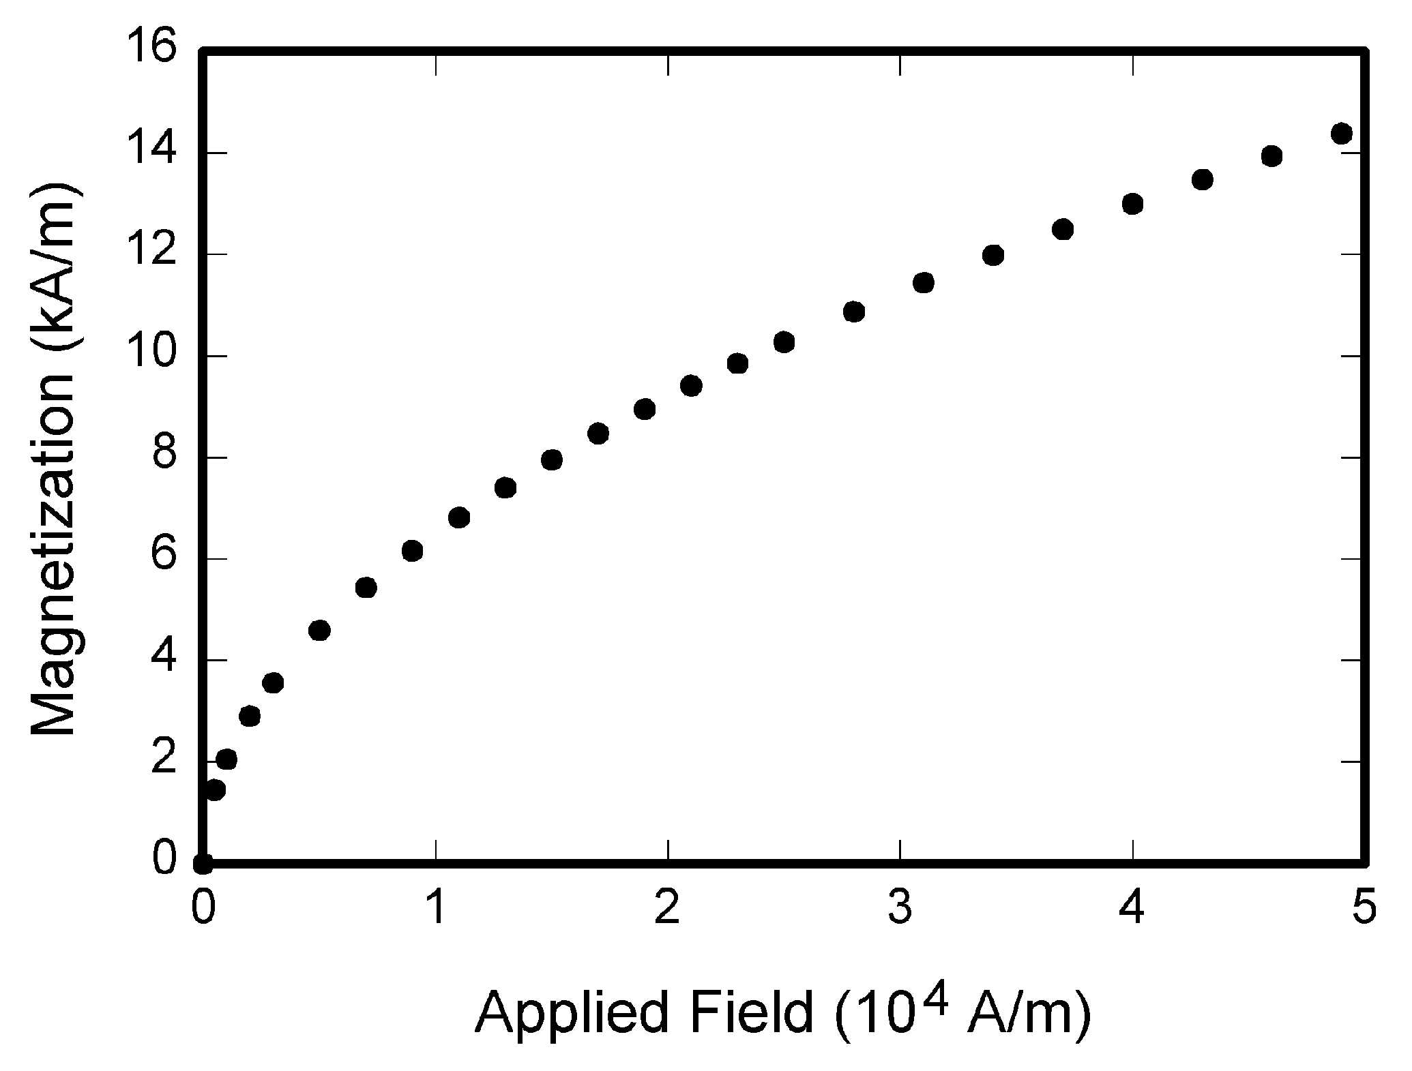
Fig. 1. The figure is center-aligned and the caption of the figure is left-aligned.

Unless it is absolutely necessary, equation numbers should not have part to them, e.g. instead of using Eq. 1(a) and Eq. 1(b). Number them as Eq. (1) and Eq. (2).

- Figures/Captions

Place tables/figures/images on the top of each column (see Table 1 and Fig. 1). Each figure or table must include a caption set in 11-point Times New Roman regular font, placed below the figure or table. The caption is left justified.
It is highly recommended that figures/images/graphs/diagrams that might have been created in other software, e.g. Excel, AutoCAD, etc., or even the ones that are composed by various graphical components (textbox, arrows, shapes, etcs.) of MS Words itself be grouped and converted to PNG (highly preferred) or an appropriate raster image format before including them in final manuscript in order to stop the linking of figures back to its sources or to avoid the graphical components scattering over the pages. The “Paste Options” in MS Word can be useful for a quick conversion. Use Drawing Canvas when necessary.
Reference to the figure should follow the format “Fig. 1”. Use “Figure 1” instead if it is at the beginning of a sentence. Figure numbering and referencing should be done sequentially, e.g. Fig. 1, Fig. 2, Table 1, Table 2., etc. Use Fig. 1(a), Fig. 1(b), etc. for figures with multiple parts.

- Sections

The heading of sections should be in 12-point Times New Roman bold font and flush left. Sections and subsequent sub-sections should be numbered and flush left in the same manner. Sections numbers are in Roman style.

  - Subsection Level 1

Use 11-point Times New Roman bold font for the heading of subsections.

    - Sub-subsection Level 2

Use 11-point Times New Roman regular font for the heading of subsubsections.

    - Sub-subsection Level 2

      - Sub-subsection Level 3

Acknowledgement

Funding supports should be acknowledged in this section.

Appendix A: An example appendix
Authors including an appendix section should do so before References section. Multiple appendices should all have headings in the style used above. They will automatically be ordered A, B, C etc.

A.1. Example of a sub-heading within an appendix

There is also the option to include a subheading within the Appendix if you wish.

References

References should be arranged by the order in which they appear in the text. Only the references that are cited in the text should be added to the reference list. Authors should follow the format as follows:

- J. K. Author, “Title of chapter in the book,” in Title of Published Book, xth ed. City of Publisher, Country if not USA: Abbrev. of Publisher, year, ch. x, sec. x, pp. xxx–xxx.
- J. K. Author, “Name of paper,” Abbrev. Title of Journal, vol. x, no. x, pp. xxx-xxx, Abbrev. Month, year.
- J. K. Author, “Title of report,” Abbrev. Name of Co., City of Co., Abbrev. State, Rep. xxx, year.
- J. K. Author, “Title of paper,” in Unabbreviated Name of Conf., City of Conf., Abbrev. State (if given), year, pp. xxx-xxx.
- J. K. Author, “Title of thesis,” M.S. thesis, Abbrev. Dept., Abbrev. Univ., City of Univ., Abbrev. State, year.
- J. K. Author. (year). Title (edition) [Type of medium]. Available: http://www.thedomainname.org [Accessed: 1 January 2016]

First A. Author and all authors may include biographies. The first paragraph may contain a place and/or date of birth (list place, then date). Next, the author’s educational background is listed. The degrees should be listed with type of degree in what field, which institution, city, state, and country, and year the degree was earned. The author’s major field of study should be lower-cased.
The second paragraph uses the pronoun of the person (he or she) and not the author’s last name. It lists work experience. Information concerning previous publications may be included.
The third paragraph begins with the author’s title and last name (e.g., Dr. Smith, Prof. Jones, Mr. Kajor, Ms. Hunter). List any memberships in professional societies. Finally, list any awards received. If a photograph is provided, it should be of good quality, and professional-looking. Below is an example of an author’s biography.

Second B. Author was born in Greenwich Village, New York, NY, USA in 1977. She received the B.S. and M.S. degrees in aerospace engineering from the University of Virginia, Charlottesville, in 2001 and the Ph.D. degree in mechanical engineering from Drexel University, Philadelphia, PA, in 2008.
From 2001 to 2004, she was a Research Assistant with the Princeton Plasma Physics Laboratory. Since 2009, she has been an Assistant Professor with the Mechanical Engineering Department, Texas A&M University, College Station. She is the author of three books, more than 150 articles, and more than 70 inventions. Her research interests include high-pressure and high-density nonthermal plasma discharge processes and applications, microscale plasma discharges, discharges in liquids, spectroscopic diagnostics, plasma propulsion, and innovation plasma applications. She is an Associate Editor of the journal Earth, Moon, Planets, and holds two patents.

مجلة كلية العراق الجامعة للهندسة والعلوم التطبيقية

نموذج الملخص باللغة العربية لمجلة كلية العراق الجامعة للهندسة والعلوم التطبيقية

المؤلف الأول ^{1،أ} ، أ ، و المؤلف الثاني ^{2، ب}
1 انتماء المؤلف الاول وعنوانه
2 انتماء المؤلف الثاني وعنوانه
البريد الالكتروني: المؤلف الاول^{ا} ، المؤلف الثاني^{ب،*} (المؤلف المسوول)

الملخص. الملخص هو نسخة مختصرة من الورقة ويجب أن يحتوي على جميع المعلومات اللازمة للقارئ لتحديد: (1) ما هي أهداف الدراسة ؛ (2) كيف تمت الدراسة ؛ (3) ما هي النتائج التي تم الحصول عليها ؛ (4) أهمية النتائج. الطول النموذجي للملخص هو 150-200 كلمة.

الكلمات الرئيسية: الكلمة الرئيسية 1 ، الكلمة الرئيسية 2 ، الكلمة الرئيسية 3 ، وما إلى ذلك.

